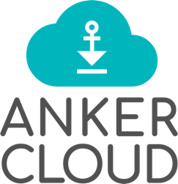

Account Manager: Harsh Saxena, Cloud Engagement
Prepared by: Akshay Kumar, Presales Engineer
Reviewed by: Arun Kumar, Head of Solutions & Delivery
Document Version: 1.0
Date: 24th December 2024

Date: 06th December 2024

Proposal for Infrastructure Migration from Azure & AWS to GCP for

DIRO LABS India Pvt Ltd.
Vishal Gupta, Founder & CEO

TABLE OF CONTENTS

TABLE OF CONTENTS 2
ANKERCLOUD SERVICES 3
TECHNOLOGY EXPERTISE 4
TECHNOLOGY PARTNERSHIPS 4
CROSS COLLABORATION WORKS 4
BENEFITS OF MOVING TO THE CLOUD 5
IS CLOUD LESS EXPENSIVE? 5
WHAT ABOUT SPEED? 5
ABOUT THIS DOCUMENT 5
INTRODUCTION 5
ABOUT THE CUSTOMER 6
SCOPE OF WORK 6
TARGET ARCHITECTURAL DIAGRAM 8
SOLUTION DESCRIPTION 8
PROJECT GOVERNANCE 9
SCHEDULE 9
PROJECT AND TEAM STRUCTURE 9
TEAM STRUCTURE 10
ESCALATION MATRIX 10
TOTAL COST AND TIMELINE OF PROJECT 10
RESOURCE MATRIX 10
TERMS & CONDITIONS 11
DURATION OF THE PROJECT 12
GENERAL TERMS 12
PROJECT VALIDITY & EXTENSION 12
CHANGE MANAGEMENT 12
JURISDICTION 12
INDEMNIFICATION 13
TERMINATION 13

ANKERCLOUD SERVICES

- Application Development, E-Commerce, Design and User Experience – Solutions that engage, enjoy and get the job done. We put the user in the centre
- Cloud and Big Data Consulting – We combine expert expertise with wide experience and help our customers with the “Digital Journey”
- We are solid advisors in the “Digital Transformation” cycle and have helped banks, healthcare, and manufacturing companies to unleash the use of Cloud, Machine Learning and Artificial Intelligence services.
- Apps and Mobile – Useful and easy-to-use enterprise app development for Android and iPhone
- AWS, Microsoft Azure, Google Cloud and Alibaba Cloud – maximize the use of these public cloud providers and help customers drive cloud adoption and digital innovation to help them grow and stay competitive.
- We are often called in to help clients straighten out derailed projects. We believe in bringing people together, working cross-disciplinary in short iterations with full transparency.
- To swiftly deliver tangible results and prototypes we work closely with client stakeholders away from ongoing longer projects, annual budgets and product launches. Our approach is based on an intensive process with technology spikes that enable us to swiftly test out both safe and bold opportunities that have a proven and relevant impact on your business.

TECHNOLOGY EXPERTISE

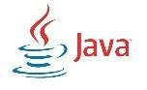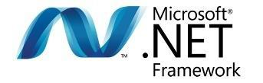
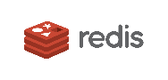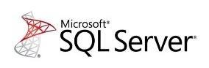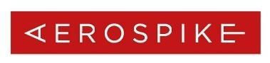
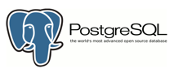
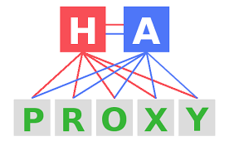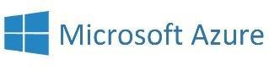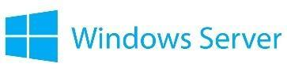
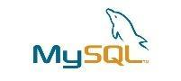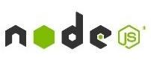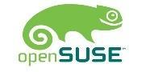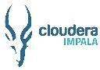

TECHNOLOGY PARTNERSHIPS

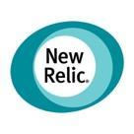 |  | 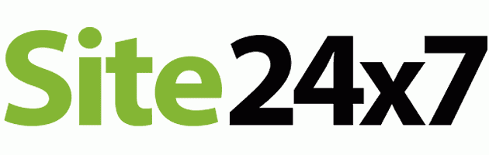 | 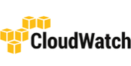 |  | 
 |  |  |  | 
 |  |  |  | 
 |  |  | 

CROSS COLLABORATION WORKS

- Our project setup will always be based on what suits your organization. Co-location and close collaboration work when you need to move fast and deliver a high-quality product. We share a focus on the product, gaining trust and objective prioritization.
- We build ambitious digital services, yet feasible with technology. Born in agile we focus on the minimum viable product, test, learn from the users and adapt instantly. Working in the same room we make the decisions swiftly and move on.
- Since we started, we have been committed to relationships. Our business is built on sustainable solutions, loyal co-workers and returning clients. We lead our clients through end-to-end projects and develop high-quality custom-built solutions across all mobile platforms, on the web and in the cloud. At Ankercloud we believe in transparency, sharing the challenges, the tests and the backlog to focus on the product.

BENEFITS OF MOVING TO THE CLOUD

From an accounting standpoint, you eliminate the capital expense incurred with a new server (or servers) and deployment, along with the required operating system and common applications (O365). Instead, you transition into an operational expense that you can plan and budget for.
From a technology standpoint, you no longer need to worry about power outages, hardware failures, offsite backups, internet outages, and expensive maintenance fees. You get rid of hardware and software obsolescence by maintaining the latest versions of the programs and features you need.
From a business standpoint, you avoid costly downtime and the need to maintain application updates across multiple systems. You gain the ability to work and access from anywhere and save thousands on deployment and maintenance costs.

IS CLOUD LESS EXPENSIVE?

When you take into consideration the cost of hardware, power, software licensing, setup, support, maintenance, and downtime, and add the benefit of location flexibility and business continuity, most companies realize a MINIMUM savings of 30% while others greatly exceed that! In this economy, that is a HUGE benefit! (Source: Gartner)

WHAT ABOUT SPEED?

For the most part, services performed in the cloud are faster than on your current network infrastructure. That is because there is no data travelling “across the wire”. All of the computer desktops and applications are stored on the same infrastructure, so access to data is immediate, unlike a local network which often has to send data across the network cables.

ABOUT THIS DOCUMENT

This document captures the Scope of Work for the migration from Azure & AWS to Google Cloud proposal between ‘Ankercloud Technologies Private Limited’ and ‘DIRO LABS India Pvt Ltd’.

This Scope of work is written and was negotiated in English, is the complete and exclusive agreement between the Parties regarding the subject matter of this Agreement, and replaces any prior oral or written communications, representations, understandings, warranties, promises, convents, commitments, or agreements between the Parties with respect to the subject matter of this Agreement.

By signing in the Acceptance section (see end of document) the parties agree to be bound by the terms of this Agreement. Once signed, unless prohibited by applicable law, any reproduction of this Agreement made by reliable means (for example, photocopy or facsimile) is considered an original.

INTRODUCTION

Cloud computing introduces a radical shift in how infrastructure and software technologies are procured, utilized and managed by large organizations. Before the cloud, if a project team needed infrastructure they would raise a request with the procurement team. On budget approval, the infrastructure team will procure the hardware which would take between 3 weeks to 12 weeks and assemble them in the data centre and then share the access to the project team. In the cloud world, the project team will have a user account with access to the cloud subscription. They can log in, create the necessary infrastructure and start using the same in a matter of minutes. Adopting the cloud in an organization involves the acceptability of changes throughout the organization. This document provides guidance that supports different parts of the organization so that all teams understand cloud adoption w.r.to adopting new practices or changing existing practices.

There are seven perspectives one should consider,
- Business
- Platform
- Maturity
- People
- Process
- Operations
Security

Organizations can use the above perspectives, components, and activities like building blocks to develop a plan and a roadmap to move from their current IT environment to a cloud-based environment, or to implement a new cloud-based IT environment.

About the Customer

DIRO is the first Bank and Address verification platform with full global coverage. Many of our clients use our technology in KYC/KYB in onboarding of consumers, vendors, and merchants. Today we work with tier 1 global banks, payment providers, lenders, wealth management, and identity verification companies. With user consent, DIRO captures source data in real-time from 44,000 banks, 9,000 utility companies, and 700 government sources in 195 countries with its patented solution.

SCOPE OF WORK
The migration project for Diro Labs aims to transition its applications and data from AWS & Azure to Google Cloud Platform (GCP), leveraging GCP's robust and scalable infrastructure to meet the growing business demands. The project begins with a comprehensive assessment of the existing AWS environment, identifying key applications and data sets that are essential for the business. A strategic migration plan will be developed, factoring in dependencies, timelines, and associated costs. This foundational phase ensures that all stakeholders clearly understand the migration process and its impact on business operations.
- Assess current AWS & Azure infrastructure.
- Identify critical applications and data for migration.
- Develop a strategic migration plan addressing dependencies and costs.
- Ensure stakeholder alignment and understanding of the process.
The GCP setup will include creating a VPC with public and private subnets, configuring Cloud Router and Cloud NAT for secure network connectivity, and implementing Cloud Load Balancing for traffic distribution. Security will be enforced using Cloud IAM, Cloud Armor (for DDoS protection), and Cloud Monitoring for ongoing health checks. Additionally, Cloud DNS and Cloud CDN will be configured to optimize domain resolution and content delivery.
Data migration will take place using Data Transfer and Database Migration Service to move databases to Cloud SQL or Cloud Spanner. Virtual machines will be moved to Compute Engine using Migrate for Compute Engine. Containerized applications will be migrated to Google Kubernetes Engine (GKE), providing scalability and efficient orchestration. Throughout this phase, we will ensure minimal downtime and data consistency, with security and performance optimization prioritized.
Ankercloud will focus on testing and validation of the migrated systems to confirm functionality, performance, and security. After successful validation, a cutover plan will be executed to switch live traffic to the new GCP environment. Post-migration, we will closely monitor the system using Cloud Logging and Cloud Monitoring to ensure smooth operations and resolve any issues promptly. This lift-and-shift migration will result in enhanced scalability, performance, and security for Diro Labs.

Target Architectural diagram
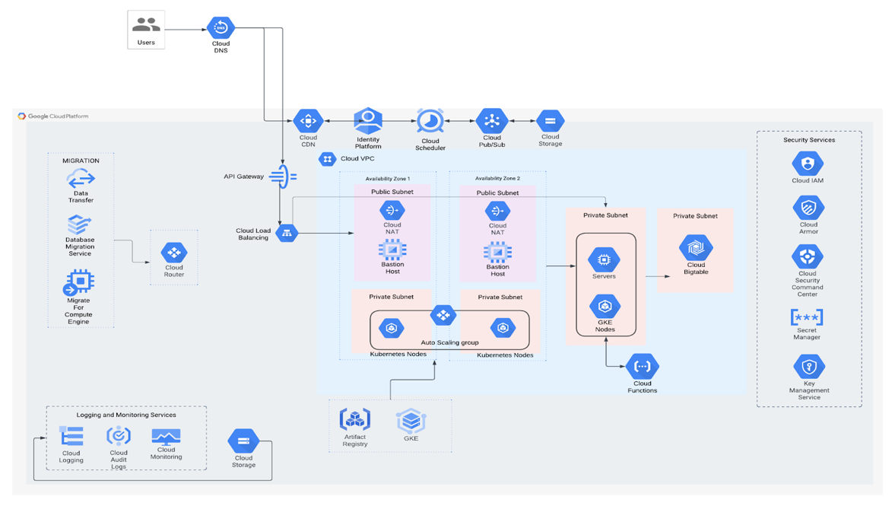

Solution Description

This architecture outlines the deployment of Diro Labs' applications on Google Cloud Platform (GCP). The goal is to leverage GCP's scalable, reliable, and secure infrastructure to deliver a high-performance and user-friendly application.

Infrastructure Layer:
- Cloud VPC: Provides a private network for secure communication between resources.
- Public Subnet: Hosts internet-facing services like load balancers.
- Private Subnet: Isolates sensitive resources from public internet access.
- Cloud Router: Manages network traffic routing within the VPC.
- Cloud NAT: Enables private instances to access the internet without public IP addresses.
- Bastion Host: Provides a secure way to access private resources.
- Cloud Load Balancing: Distributes incoming traffic across multiple servers.
- Cloud DNS: Provides a reliable and scalable DNS service.
- Cloud CDN: Improves website performance by caching content at edge locations.
Application Layer:
- GKE: Manages and orchestrates containerized applications.
- Kubernetes Nodes: Host containerized applications.
- Servers: Traditional virtual machines for specific workloads.
- Cloud Functions: Executes serverless functions in response to events.
- Cloud Pub/Sub: Enables asynchronous communication between services.
- Cloud Storage: Stores static assets like images and videos.
- Cloud Bigtable: NoSQL database for large-scale, low-latency data storage.
- API Gateway: Exposes APIs to clients and manages API traffic.
Developer Tools:
- Data Transfer: Facilitates efficient data transfer from other sources to GCP.
- Database Migration Service: Migrates databases to Cloud SQL or Cloud Spanner.
- Migrate for Compute Engine: Migrates virtual machines to Compute Engine instances.
- Artifact Registry: Stores container images and other artifacts.
Security and Monitoring:
- Cloud IAM: Manages access control for GCP resources.
- Cloud Armor: Protects web applications from DDoS attacks.
- Security Command Center: Provides a centralized view of security posture.
- Secret Manager: Stores and manages secrets securely.
- Key Management Service: Manages cryptographic keys.
- Cloud Monitoring: Monitors the health and performance of GCP resources.
- Cloud Audit Logs: Records user activity and system events.
Cloud Logging: Centralizes and manages logs.

Workflow: Migration to GCP
- Assessment and Planning:
  - Evaluate the current infrastructure and identify applications and data to be migrated.
  - Develop a migration plan, considering factors such as dependencies, timelines, and costs.
- Infrastructure Setup:
  - Create a VPC with public and private subnets.
  - Configure Cloud Router and Cloud NAT for network connectivity.
  - Set up Cloud Load Balancing to distribute traffic.
- Data Migration:
  - Use Data Transfer and Database Migration Service to migrate databases to Cloud SQL or Cloud Spanner.
  - Migrate virtual machines to Compute Engine instances using Migrate for Compute Engine.
- Application Migration:
  - Containerize applications and deploy them to GKE.
  - Configure load balancing and firewall rules.
- Testing and Validation:
  - Thoroughly test migrated applications and data to ensure they function correctly in the GCP environment.
  - Validate performance and security.
- Cutover and Go-Live:
  - Implement a cutover plan to switch traffic from the existing infrastructure to GCP.
  - Monitor the migrated environment closely during and after the cutover.

Timeline & Costing

Timeline - 30 Days
Resource - 1 (Cloud Architect)
1 (Senior Cloud Engineer)
1 (Senior DevOps Engineer)
1 ( Project Manager )

Resource Matrix
S.No | Name | Man Days
1 | Cloud Architect | 05
2 | Sr.Cloud Engineer | 20
3 | Sr.DevOps Engineer | 10
4 | Project Manager | 05

AWS TO GCP PRICING CALCULATOR: - https://cloud.google.com/products/calculator?hl=en&dl=cjhdavf5wmpsavpewmtnata1wxpobuxuutbobul0wvrwa1ppmdfoakl4wwpvd1puqtfor1vrqve9prakgirdnjc5rdncqi0zmuq4ltqwotgtodewrc0wmeu5meiwmey1oui

Data Transfer Link: https://cloudpricingcalculator.appspot.com/#!?id=2dec1c2c-c619-4967-913c-3bc425185f45#resultBlock

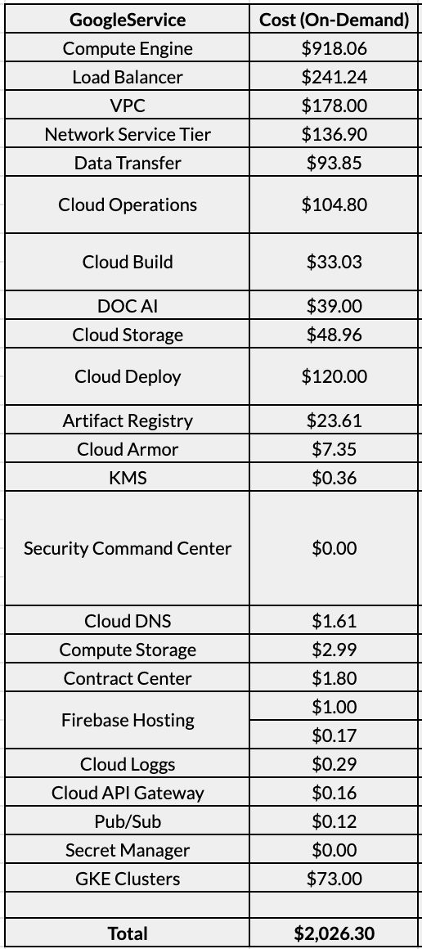

Azure to GCP Pricing Calculator:
https://cloud.google.com/products/calculator?hl=en&dl=CjhDaVF6WXpZNE5ETTVaaTAxT0RBMUxUUXhOVGt0T0RBME5TMWpOMlF4WW1NMU9EWXlZemNRQVE9PRAIGiRGMDQwMjNFQS02QjE4LTRFNzMtODdFOS0zOUIyNzM2NDNDQUQ

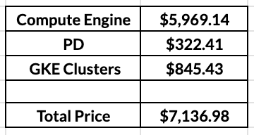

Project Validity & Extension
This Agreement between Ankercloud Technologies Private Limited and DIRO Labs India Pvt Ltd shall remain in effect for as long as any Scope of Work incorporating this Agreement is in effect.
- The term of this Agreement begins on the Service Kick-off Date as indicated in the section titled “Schedule” and continues for the duration outlined in the Scope of Work. Ankercloud Technologies Private Limited and DIRO Labs India Pvt Ltd may agree to additional terms by issuing an agreement extension. If the Kick-off date is not mentioned in the Agreement, the same can be amended in a supporting document with an email confirmation while this Agreement is valid.
- In the event of additional work extensions, Ankercloud Technologies Private Limited will ask DIRO Labs India Pvt Ltd to issue a formal work order with relevant commercial terms.

CHANGE MANAGEMENT
Change management refers to the formally agreed upon approach between Ankercloud Technologies Private Limited and DIRO Labs India Pvt Ltd to create or raise additional Scope of Work or Work extensions not captured in the original scope of work. Ankercloud Technologies Private Limited and DIRO Labs India Pvt Ltd will mutually agree to a formal Change management request to accommodate any such changes that either add to the scope of existing Design, Implementation or Service Assurance or modify existing scope. Pricing changes that accompany change management will be considered as additional price items over existing commercial terms.

JURISDICTION

The terms of this Statement of Work and the ensuing project scope will be administered under the jurisdiction of the Bangalore courts.

INDEMNIFICATION

The indemnification obligations set forth in this Section shall be the parties' exclusive rights and remedies with respect to this Agreement.
Indemnity by DIRO Labs India Pvt Ltd– DIRO Labs India Pvt Ltd shall indemnify and hold harmless Ankercloud Technologies Private Limited, Ankercloud Technologies Private Limited’s affiliates, and each of their respective officers, directors, members, agents and employees from and against any and all claims, demands, liabilities, obligations, losses, damages, penalties and fines of any kind and nature whatsoever (including reasonable attorneys' fees) brought by a third party under any theory of legal liability arising out of or related to any of the following: (i) the actual or alleged use of the Services in violation this Agreement or (c) applicable law or (ii) any breach by DIRO Labs India Pvt Ltd of any of its obligations under this Agreement.
Reciprocal Indemnification - Each party shall indemnify and hold harmless the other party, the other party's affiliates, and each of their respective officers, directors, members, agents and employees from and against any and all claims, demands, liabilities, obligations, losses, damages, penalties and fines of any kind and nature whatsoever (including reasonable attorneys' fees) brought by a third party under any theory of legal liability arising out of or related to the indemnifying party's actual or alleged: (i) gross negligence, (ii) wilful misconduct or (iii) infringement or misappropriation of a third party's copyright, trade secret, patent, trademark or other intellectual property right.

Termination

By DIRO Labs India Pvt Ltd– DIRO Labs India Pvt Ltd may terminate this Agreement before the expiration of the Initial Term or any Renewal Term without liability to Ankercloud Technologies Private Limited (except for amounts due for Services through the effective date of such termination) as follows: (i) Ankercloud Technologies Private Limited fails in a material way to provide the Design and in accordance with the terms of this Agreement and does not cure the failure within 15 days following receipt of DIRO Labs India Pvt Ltd.’s written notice describing the failure in reasonable detail; (ii) Ankercloud Technologies Private Limited materially violates any other provision of this Agreement and fails to cure the violation within 30 days following receipt of DIRO Labs India Pvt Ltd.’s written notice describing the violation in reasonable detail.
By Ankercloud Technologies Private Limited - Ankercloud Technologies Private Limited may terminate this Agreement before the expiration of the Initial Term or any Renewal Term without liability to DIRO Labs India Pvt Ltd as follows: (i) upon not fewer than 5 days written notice, if DIRO Labs India Pvt Ltd is overdue by more than 30 days on the payment of any amount due under this Agreement; which overdue payment shall continue to be due and payable by DIRO Labs India Pvt Ltd following such termination (ii) India Pvt Ltd materially violates any other provision of this Agreement and fails to cure the violation within 10 days after a written notice from Ankercloud Technologies Private Limited describing the violation in reasonable detail or (iii) after notice to DIRO Labs India Pvt Ltd of at least 30 days if Ankercloud Technologies Private Limited is threatened with a claim for intellectual property misappropriation or infringement related to Scope of work.

SEVERABILITY

In the event that any provision of this Agreement is deemed or becomes invalid, unenforceable, or is found to be incomplete, the validity of the remaining provisions hereof will not be affected thereby. In such a case, the invalid or unenforceable provision or the incompleteness will be replaced or filled by a valid and enforceable provision which, in its economic effect, the Parties would have chosen on entering this Agreement in order to preserve the purpose of this Agreement to the greatest extent possible.

ACCEPTANCE AND SIGNATORIES TO THE STATEMENT OF WORK

DIRO Labs India Pvt Ltd’ verifies that the terms of this Statement of Work and Service Level Agreements are acceptable. The parties hereto are each, acting with proper authority by their respective companies.
For Ankercloud Technologies Private Limited

Full Name of Authorized Signatory & Designation

Name: Santhosh Jayaprakash
Designation: Founder & CEO
Date: 24th December, 2024

For DIRO Labs India Pvt Ltd

Full Name of Authorized Signatory & Designation

Name: Mr. Vishal Gupta
Designation: Founder & CEO
Date: 24th December, 2024

